
BIDBOX

View Beneficiary Details

25th January 2019

Steps

- Login to BidBox as a master admin

- Navigate to settings >> Companies and register a company. Once successful you will be redirected to the companies list.

- Under companies list, click on Users >> Add new company user. This will be the company administrator.

- Log out and login with the company admin credentials. Kindly use a valid email address when registering the admin.

- Navigate to Applications >> Company Users and add a new company user. He/ she will be responsible in making applications on behalf of the company.

- Log out and login with the company user’s credentials. The option to register a beneficiary has been implemented as shown below:

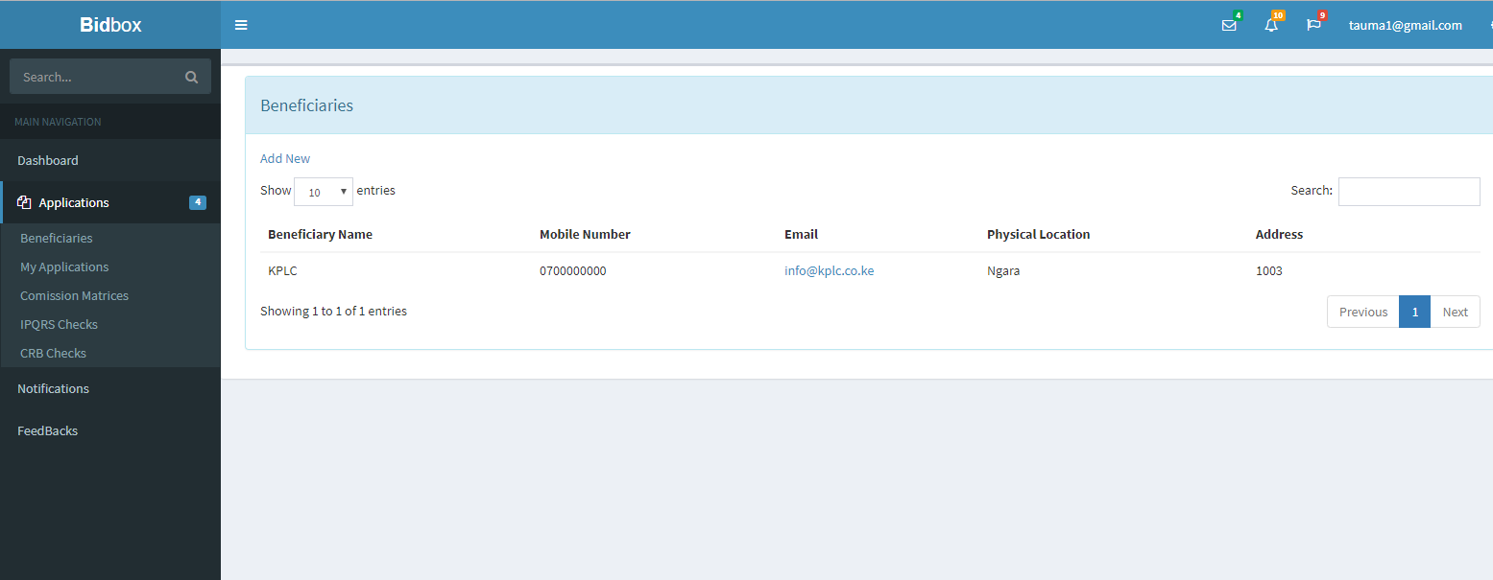

Figure 1: Register Beneficiary

- Navigate to my applications and make an application. The option to add preferred period has been implemented. Choose the preferred beneficiary and click on save. Once successful, you will be redirected to your applications page as shown below.
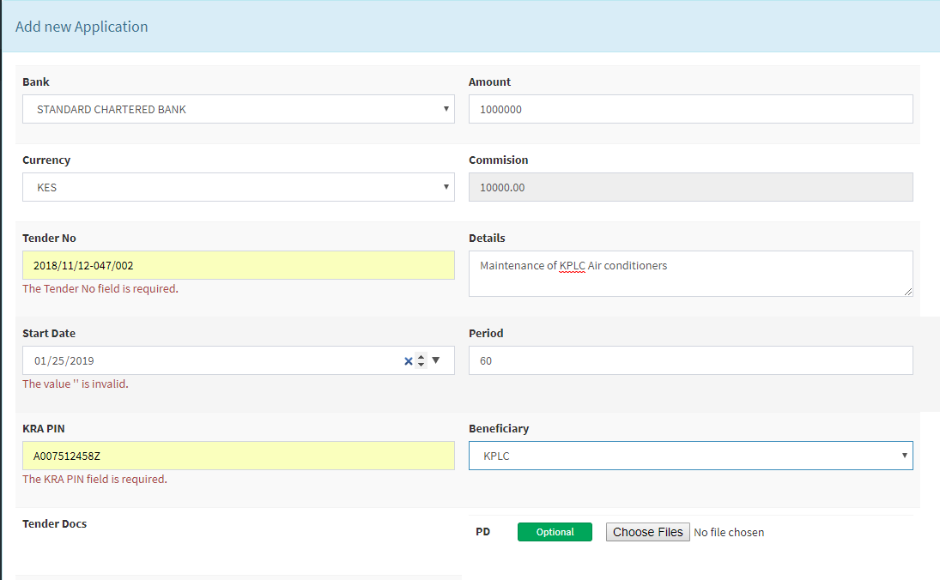
Figure 2: Make application

- On the applications list, click on Details to view the application details. The details will be displayed similar as shown below. The applicant and the beneficiary details are now available.

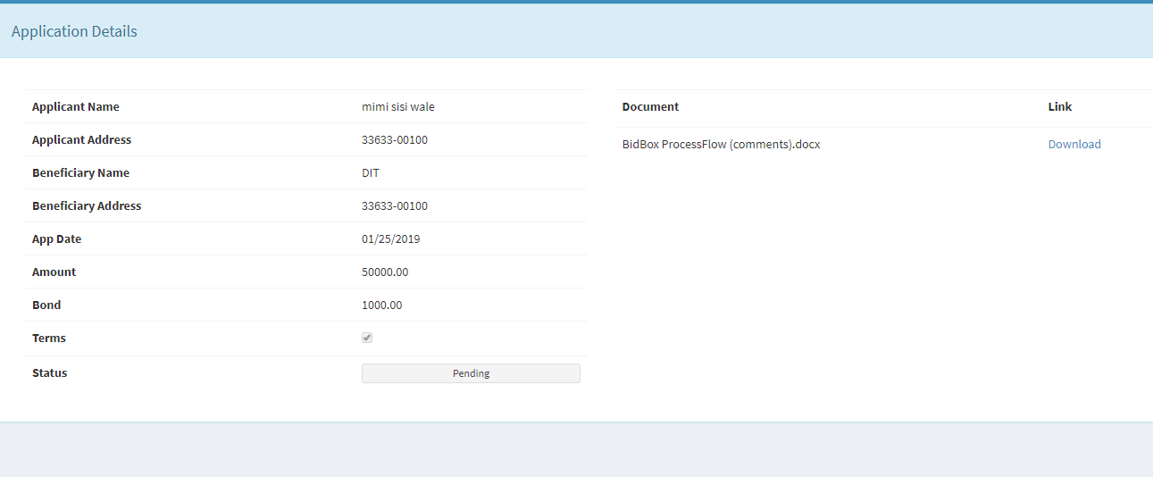
Figure 3: Application Details

